**CHMSC BAO MANAGEMENT AND MONITORING SYSTEM**

**Chapter I**

**INTRODUCTION**

**Project Context**

Recent developments in the field of available ICT (Information and Communication Technologies) resources have led to a renewed interest of learners in knowledge acquisition through various means. It makes students better prepared, better skilled and more informed in comparison to their earlier counterparts. Among leading school institutions, knowledge management has become prime requisite. Information dissemination in education has seen an enormous flow because of Internet. Website of schools has been essential requirement to stand themselves among competitors. (Dr. J Durga Prasad Rao, 2014)

Modern technology has taught us a great deal about computer system. It helps us to make our work faster and easier. Most people depend on a technology right now. It gives a big work impact to our every life. A computerized work to handle their needs, and efficient way for the effectiveness of managing a business. The Business Affairs Office of Carlos Hilado Memorial State College (CHMSC) provides the leadership and direction in the management of CHMSC’s business enterprises such as the short and long term leases of campus assets such as chairs and canteen rental, lodging, fishponds inventory and reservation of convention hall.

According to the management of the Business Affairs Office of Carlos Hilado Memorial State College-Binalbagan campus, managing and monitoring is very important when it comes in handling a business such as reservation of convention hall, canteen and chairs rental, lodging of dormitory and hometel and fishpond inventory. Management and monitoring serve as the basis of the most effective way of handling a business.

According to Miss Gina Pamplona the personnel-in-charge in handling business transaction their way of dealing, monitoring, managing, and the inventory of the business inside the campus of CHMSC-Binalbagan is manual and time consuming. There are some cases that they can’t avoid some misplace or difficulty of finding files. Also there are instances when they forget to take down the list of the business transactions with clients. Some personnel forgot to record a transaction or miscounted the number of items.

Hence, the proponents of this study come-up with an idea to develop a computerised system for the Business Affairs office of Carlos Hilado Memorial State College-Binalbagan campus.

According to the interview conducted by the proponents, it can take longer time and effort for the personnel-in-charge to manage or handle every transaction of the clients. The proponents proposed a system that will improve the operation of the business affairs office. Moreover, to have a quicker and more systematic way to record all the important information. The system will also provide a standard quality for security.

**General Objectives:**

The main objective of this study is to develop a management and monitoring system of Business Affairs Office of Carlos Hilado Memorial State College Binalbagan campus that can accommodate the business transaction of the clients.

**Specific Objectives:**

1. To design and develop a computerized and organize flow of records of every transaction between the clients and the admin.

2. To manage and monitor all the client’s balances in every asset in terms of payment of rent.

3. To secure all the transactions of the clients that had been encoded to the system.

**Purpose and Description**

The purpose of the proponent’s developed system is to help Carlos Hilado Memorial State College Business Affairs Office to replace its current manual system. The system will provide an organize flow of transactions between the clients and the admin and to keep the data in a secure place. This system also enhances the personnel-in-charge to coordinate with clients by providing a good services and to meet the wants of every client.

The Carlos Hilado Memorial State College-Binalbagan Business Affairs Office Management and Monitoring system is design to provide the business affairs office personnel-in-charge a systematic way of client’s transactions including the managing, monitoring and updating of the client’s information and transactions to the admin. The personnel-in-charge will be the one to encode all the transactions of the clients. The encoded data will be automatically stored in the database of the system.

The said system is an offline system that will assure a proper management to every business transaction of the clients and to avoid conflicts with the other. Also, the system aims to lessen the difficulties in terms of handling a business. This system is server base with desktop platform.

The server run to save every data into the database and the system will organize and process all the data input.

**Scope and Limitation**

The CHMSC-Bin BAO Management and Monitoring System is intended only for the Business Affairs Office of Carlos Hilado Memorial State College - Binalbagan campus. It only focuses on management and monitoring the business inside and out of the campus, such as Student Dormitory, Hometel, Reservation for Convention Hall, Fishpond Inventory, Rental of chairs, and Canteen Tenants. The System is only exclusive for the admin of CHMSC-Bin Campus Business Affairs Office who can benefit to this new way of business transaction. The admin will only focus on the businesses mentioned above and nothing more.

**Significance of the Study**

The study will be significant and essential to the people whose involve in this system. It can be a big help for them to well manage and monitor as well as to organized the whole CHMSC businesses in terms of:

**CHMSC-Bin Business Affairs Office:** the result of this study will provide the user an effective and efficient way of handling a business. This study also will help the BAO to arise some necessary actions and a faster scheme of managing and monitoring the business transaction in a more applicable and manageable way.

**The Business Affairs Office Personnel:** this study will help the admin who is responsible for keeping the files to keep it safety and properly.

**Future Researchers:** the result of this study will offer significant information to future researchers in conducting similar studies. This study will serve also as a reference for future undertakings.

Staff – this study can help also to the staff who is helping for the admin in gathering some business information from the customer.

Student – this study can

**The Researcher:**  this study is an additional exposure on the part of the researchers to advance their skills in creating research paper and making as one of the credential for future purposes.

**Definition of Terms**

For the classifications of particular words used in the proposed system, the key word that has been used in this study will be defined as follows:

**Canteen –** In the dictionary, it is refers to a store in a camp, school etc. In this study, it is refer to the place where the tenant rent to sell a product.

**Chairs** - In the dictionary it is refers a seat for one person that has a back and usually four legs.

In this study, it is refers to the things that the person rent.

**Convention Hall** – is a place where some activities or programs can be held on.

In this study, the term used to a venue or place of any activities inside the campus like for example for a symposium.

**Dormitory –** is a place where someone can stay on.

In this study, the term was used toa place where students can stay in.

**Fishpond Inventory** – composed of list of the quantity and quality of the fish as well as the feeds consumed.

In this study, the term was used to a complete list of fish that are coming in and out as well as the feeds of fish.

**Hometel** – is a place where someone can stay on.

In this study, the term was used to a place where outside visitors of CHMSC can stay in.

**Manage –** is the act of handling or dealing something that is needed to be manage.

In this study, the term managing refers to the systematic process in handling a business.

**Monitoring –** is the act of watching or observing the process in maintaining a business well functioned.

In this study, the term monitoring used to the systematic process of collecting, analysing the transaction between the admin and the clients to reach its objectives and to guide management decisions.

**Chapter II**

**REVIEW of RELATED LITERATURE and PRIOR ARTS**

This chapter presents the reviews of related works and studies that deals managing and monitoring businesses. The scope of these concepts provides multiple articles from different sources were used to familiarize and to authenticate the needed data for the study.

**Related Concepts**

The proponents conducted a research with use of books and internet to provide related literature and prior arts system that are applicable in the development of the system.

**Local Related Literature**

**Integrated Sales and Inventory Management System Implemented In Three-Tier Architecture**

According to Joseph Brylle N. Cambronero, Nikko Andrew F. Labadan, Hyla Kay D. Labio, Ralph Jan B. Redoña, Bernil Jane F. Salarda (2010). The purpose of this project was to identify and solved the problems regarding the inventory monitoring and sales management. Business industries encountered many problems in terms with their business process. Jorona Aquatic Resources and International Trading,Inc. is a company for marketing aquatic resources internationally and in domestic place here in the Philippines. The said company encountered difficulties in rendering quality service, making effective marketing strategies, communication, and security. During the analysis made by the proponents, they encountered issues that slow the processes of business and impede possibly, the rapid growth of income. They found that Integrated Sales and Inventory Management system solved the current problems of the company. They discussed how much the system cost, how it will work, what are the benefits that the company would get if they will apply it and the impacts towards the employees.

The project was made for almost three semesters from second semester AY 2008-2009 to 2009-2010. After all the tests and evaluations, as compared to the manual system and other alternatives that the company used to enhance the company’s business processes, the said system was cheaper, faster, could lessen the human resource, effective, and efficient way in gaining hefty profit. It reduced failure reporting and analysis, and could provide timely and accurate reliability/quality reports. The proponents highly recommended for the enhancement of the system to include online payment, automate the delivery details and transaction recording, and include computations in all accounting transactions.

**Computerized Reservation System (CRS)**

According to Angelie Marie L. Vizconde and Sevillia S. Felicen(2014).This study was conducted to fully understand the use of computerized reservation system in travel agencies. Specifically, it seeks to answer the following objectives; to determine the most common e-reservations system used in travel agencies; to discuss the effects of e-reservation system in the operation of travel agencies; to determine the problems encountered by travel agencies in using reservation system and discuss the implications of the using e-reservation system in operation of travel agencies in as far as customer relations and satisfaction are concerned. The study focuses only in travel agencies that were served by CRS ven-dors, particularly subscribers in Metro Manila. The descriptive method of research was used in the study. Instruments like questionnaire and interview were further utilized in gathering the primary data. The data gathered were statistically treated using weighted mean. Data revealed that computerized reservation system has a positive effect in improving company’s efficiency and productivity. As a whole both the positive and the negative effects of CRS contributed much to the development of travel agencies and the tourism industry. CRS is one of the most important tools of any travel agencies to generate more profit and to achieve total guest satisfaction and ensure customer retention.**Inventory System**

According to the study of Christian Bernese, Jayce Marin, Regie Millan, and Heavenlyn Porcado (2015), Inventory System is a specific implementation of an inventory service and it is used to plan and track inventory balances and activities. Inventory is basically the total amount, number of stocks and records of supply or materials of a store and other business. Philippine Computer Company (PhilCom) is specialized in buying and selling computer parts and offers brand new and second hand computer materials. They also offer computer services like computer check-up, assembling and formatting. Point of Sale (POS) is an electronic system designed to help business maintain and analyze inventory and transaction occurs in exchange for goods and services.

Inventory System is somewhat similar to the proposed system that also aims to have a secured data and to designed a system that would help to make an easy way of calculating the number of stocks and the total amount or number they used. To help business maintain, analyze inventory and transaction data on a continuous basis. It helps the system to review the stored data.

**Foreign Related Literature**

**Library Management System**

According to E. Valenti 2016 from the article entitled “The State of Library Management System” are system that helps big in terms of some transactions on the library. On this article the automated library system said that it can do multitasking. It can do recording books on library but it can also make different transactions. It will make the library service convenient like making card cataloguing. Therefore, multitasking inside the library is very nice.

The system will be the one who records all the transactions inside the library so it decreases the task of the librarian so it can avoid the cases of lost records due to human errors (Valenti E, 2016).

**Automated Sales and Inventory System**

According to Jayson Tamayo (2014), to overcome the deficiencies of manual system, many companies have automated their inventory system. This system is used to track or monitor the merchandise and goods of a retail store with an automated Sales and Inventory System, business rely on computers to do task that were once performed manually, such as inventory check and products sales. Automated Sales and Inventory System these processes can be handled in a timely manner and also be more accurate and reliable than ever before (Hartman, n.d.). It provides greater accuracy and more flexibility in the types of information and reports than can be generated by the system.

This study is may similar to the proposed system in which it also aims to monitor or track all of their stocks and provides greater accuracy in their inventory reports.

**Hospital resource and patient management system**

According to Musa A. Lancashire(2013). One of the major challenges existing hospital management systems face is around operational efficiency and wait times between different processes, departments and persons. This paper highlights such

limitations of existing systems and proposes a RFID (Radio Frequency ID) and wireless sensor based, location and information management framework that facilitates real time tracking of hospital assets, personnel and patients as they move through pre-set procedures as part of daily activities of the hospitals. The system covers the visual simulation and providing ability to analyze the ongoing operations so they can be corrected to achieve increased process efficiency and service levels.

It is similar to the proposed system in terms of facilitating every component.

**Computerized Inventory Management System**

According to Thomas M. McHugh (2011) computerized inventory management systems provide many benefits that are hard to obtain using paper methods or an in-house spreadsheet. Systems that are specific to the lab can be used relatively quickly without a significant learning curve or system customization. The ability to analyze the inventory, item usage, purchasing history, and other areas (e.g., lot numbers, equipment) are important improvements to spreadsheets and paper systems. If the system includes equipment tracking, it can be used to determine the capital asset as well as track the service history and lifespan of equipment. The ability to streamline and automate many of the inventory control tasks will be increasingly important to reduce hands-on time while improving the analysis of trends, reducing stock-outs, and avoiding expiring reagents. The ability to ensure that the right reagent in the right quantity is present at the right time is critical to laboratory operations. Given that reagents are approximately one-half of most labs' operating budgets, a continued focus on this expense will assist the laboratory in continuing to provide accurate and timely laboratory testing at the lowest cost.

**TABLE OF COMPARISON**

Table 1. CHMSC BAO management and monitoring system feature Comparison Table of Related Application and System.

|  |  |  |  |  |  |
| --- | --- | --- | --- | --- | --- |
| Related  Prior Arts | Features | | | | |
|  | Connectivity | Scheduling | Monitoring | Security | Platform |
| **Integrated Sales and Inventory Management System Implemented in Three-Tier Architecture** | ONLINE | YES | NO | YES | DESKTOP  / ANDROID |
| **Computerized Reservation System (CRS)** | LAN | YES | YES | YES | DESKTOP |
| **Inventory System** | LAN | YES | NO | YES | DESKTOP |
| **Library Management System** | LAN | YES | NO | YES | DESKTOP |
| Automated  Management and Monitoring System | OFFLINE | YES | YES | YES | DESKTOP |
| **Automated Sales and Inventory System** | OFFLINE | YES | YES | YES | DESKTOP |
| **Computerized Inventory Management System** | LAN | YES | YES | YES | DESKTOP |
| **Hospital resource and patient management system** | LAN | YES | NO | YES | DESKTOP |

This system is similar to the proposed system in terms of reducing hands-on time and analyzing inventory.

Conclusion:

Table 1 shows the comparison of related application and system, this shows what are the existing application and the system that can be compare to develop the project. This includes their features such as connectivity, security and applications.

**Chapter III**

**RESEARCH DESIGN AND METHODOLOGY**

This chapter discusses the design and methodologies that will provides the management to help identify the production output and enhance the purpose of this study. It also states the System Development Life Cycle that the proponents will use in developing system.

**Research Design**

This study is a descriptive-developmental research on the development of Business Affairs Office (BAO) Management and Monitoring System for Carlos Hilado Memorial State College-Binalbagn Campus, Enclaro, Binalbagan, Negros Occidental.

The Agile Development life Cycle is the model used by the proponents for the development of the system since it is iterative and incremental progress as it met the stages of the software (system) development life cycle. The continuous cycle and repetitive development of every stages helps to furnish the proponents system drive through by the participation of the client which will be the person who’ll be using the system.

The system will be evaluated by the selected user inside of Carlos Hilado Memorial State College – Binalbagan Campus using the standardized ISO Systems and Software Quality and these are the ISO Systems and Software Quality Requirements and Evaluation (SQuaRE) instrument or ISO/IEC 25022 Software

Quaity for the participants of the study to evaluate the acceptability of the system. Both instruments are interpreted as the following:

Table 3. ISO/IEC 25022 and McCalls’s Evaluation Numerical and Descriptive Interpretation.

|  |  |
| --- | --- |
| Numerical  Rating | Descriptive  Interpretation |
| 5 | Very Good |
| 4 | Good |
| 3 | Average |
| 2 | Fair |
| 1 | Poor |

**Agile Development Cycle (Software Development Life Cycle)**

The Agile Development Cycle analysis and design is an approach that is intended to facilitate the development of systems that must change rapidly in response to dynamic business environments.

Agile Development techniques are thought to work well in situations in which complicated information systems are undergoing continuous maintenance, adaptation and redesign.

Agile Development Cycle

Planning

Finalizing

Designing

z

Testing

Developing

Figure 1. Agile Development Cycle SDLC Model

Figure 1 shows the step by step so that the problems that right encountered can be polished by reviewing every step. Agile development cycle implies an alternative and incremental method of management. The Agile Development Software Development Life Cycle (SDLC) has five important steps needed to be encompassed in order to produce a full–developed system.

**Planning –** Proponents started from gathering data in the main office of CHMSC-Binalbagan BAO by the interviewing the staff, and other personnel. After gathering data, proponents started setting a plans to help the team identify the scope and limitations, objectives and purpose of the system. It helps also to manage the staff to ensure the project will be deliver on time.

**Designing** – The system design should be a user-friendly interface so that the user can easily access the system and follow the process on how to use the system. First, the proponents just create a sample design and consult to the client if there have a suggestion to the design in order to provide by the proponents.

**Developing** – After the Design Phase, the proponents will start developing the design they create that connected to the system that been required.

**Testing**

This phase involves the testing of the system if it’s already functional and meet that desired requirements of the end-user.

**Finalizing**

After the testing, finalizing of the system follows, during this phase the proposed system will be installed in the production process; the user will be trained or will be guided on how the system works.

**Context Diagram**

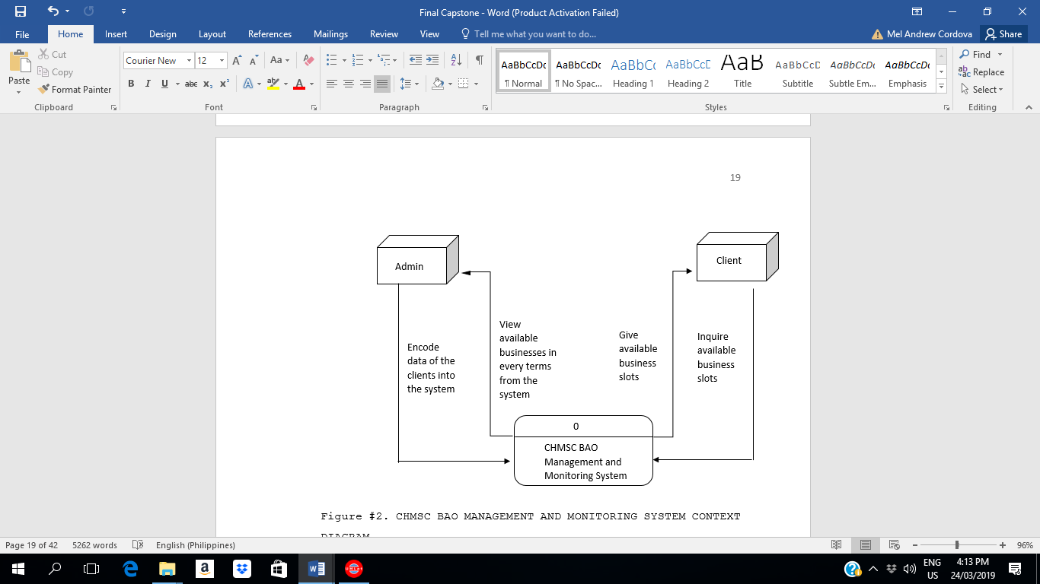The context diagram shows the general flow of processes of the developed system where an entity concerned is connected to main process. It also portrays the general input requirements and its processed output.

Figure #2. CHMSC BAO MANAGEMENT AND MONITORING SYSTEM CONTEXT DIAGRAM

Figure above shows the general processes of the developed system. It also demonstrates the input requirements needed to be filled-up by the administrator and the expected processed output from the system.

All the concepts of this study is applied in this diagram to help the management in having an accurate result in terms of reservation and monitoring.

**Data Flow Diagram**

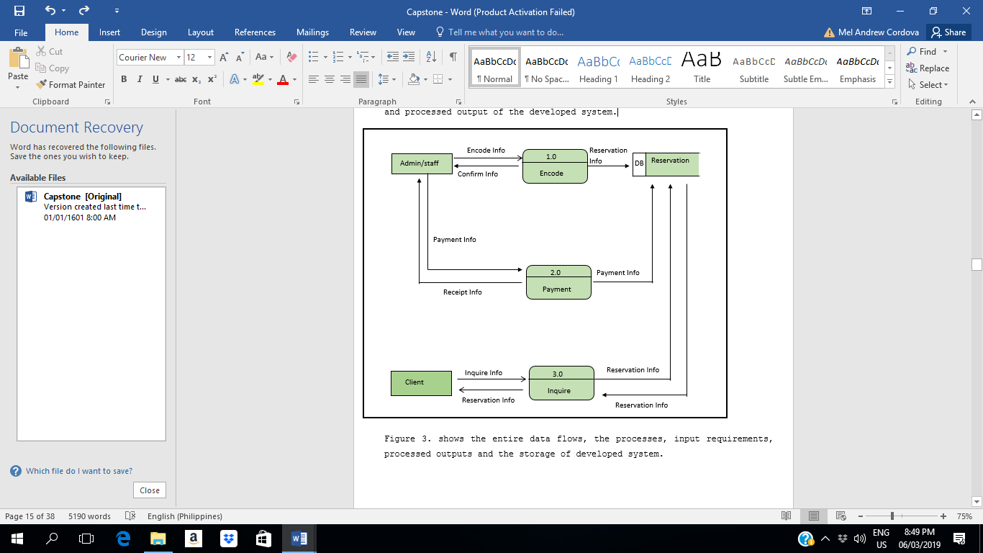The Data Flow Diagram illustrates the flow of data, input requirements and processed output of the developed system.

Figure #3. CHMSC BAO MANAGEMENT AND MONITORING SYSTEM DATA FLOW DIAGRAM

Figure above shows the entire data flows, the processes, input requirements, processed outputs and the storage of developed system.

**Use Case Diagram**

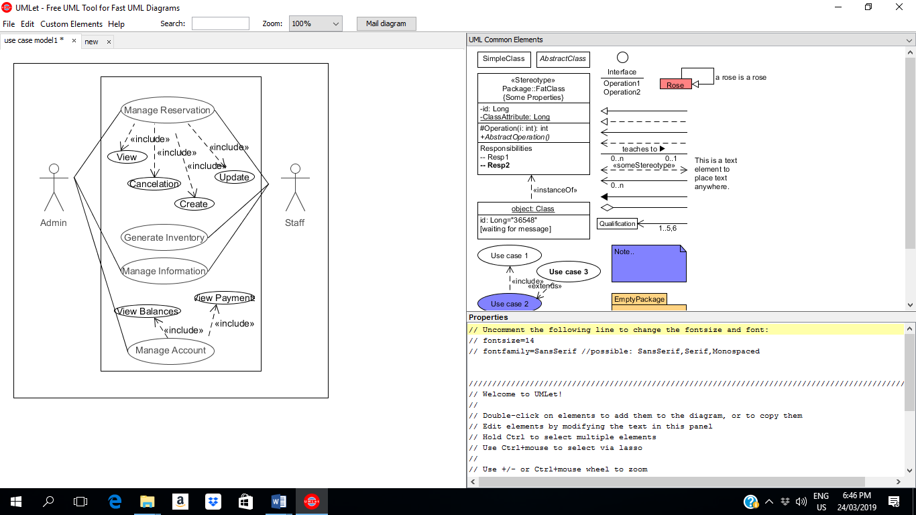The use case diagram shows the user’s interaction with the system and its relationship between different use cases and the user is involved.

Figure #4. CHMSC BAO MANAGEMENT AND MONITORING SYSTEM USE CASE DIAGRAM

Figure above shows the major tasks that actors must be done in order to implement the system. As the figure shows, the clients transact a business and the admin has all the job to perform with the help of the staff in order for the system to implement.

The corresponding use case description for the above actors are:

**Actors:** Admin and Staff

* **Admin:** Handle the business transactions of the client.
* **Staff:** Help the admin to handle the business transaction.

**Use Case Description**

Table below describes the function, conditions and alternative flows to be met of the actors used in the use case diagram.

Table 2. Manage Reservation

|  |  |
| --- | --- |
| Use Case Name | Manage Reservation |
| Primary Actors | Admin  Staff |
| Pre-Conditions | Admin- Have a business talk to the client base on a business that will going to reserve.  Staff- Receive information from the customer. |
| Alternative Flows | Admin- Reserve details about the reservation.  Staff- Give details to the admin in the office. |
| Post-Conditions | Admin – Give a scheduled of a reservation.  Staff- Give reserved scheduled to the costumer. |
| Main Success Scenario | Admin – Provide an output about the reserve schedule.  Staff- Provide an output and give it to the admin. |

Table 3. View

|  |  |
| --- | --- |
| Use Case Name | View |
| Primary Actors | Admin |
| Pre-Conditions | View the available slots from the system |
| Alternative Flows | Admin will inquire the client if the business is available or not. |
| Post-Conditions | Record of the available businesses can be viewed. |
| Main Success Scenario | Record can be viewed. |

Table 4. Update

|  |  |
| --- | --- |
| Use Case Name | Update |
| Primary Actors | Admin |
| Pre-Conditions | The admin must update every details of the business. |
| Post-Condition | List of every details of the businesses. |
| Alternative Flows | No alternative flows  . |
| Main Success Scenario | All the list of the information is updated. |

Table 5. Cancelation

|  |  |
| --- | --- |
| Use Case Name | Cancelation |
| Primary Actors | Admin  Staff |
| Pre-Conditions | Admin and Staff cancel the reservation if the customer will back out. |
| Alternative Flows | The admin and staff gather the final decision of the customer. |
| Post-Conditions | Reservation will be canceled. |
| Main Success Scenario | Available to another customer. |

Table 6. Encode Data

|  |  |
| --- | --- |
| Use Case Name | Encode Data |
| Primary Actors | Admin |
| Description | Admin will encode all the data’s in order the files to be safe. |
| Pre-Conditions | Receive business data from the customer. |
| Alternative Flows | Manage the data. |
| Post-Conditions | Encode the data into the system |
| Main Success Scenario | Keep the files safe.. |

Table 7. Generate Inventory

|  |  |
| --- | --- |
| Use Case Name | Generate Inventory |
| Primary Actors | Staff |
| Pre-Conditions | Staff will monitor the sales and uses of every businesses. |
| Alternative Flows |  |
| Post-Conditions | The sales and item uses will counted |
| Main Success Scenario | Know the capital and profit. |

Table 8. Manage Information

|  |  |
| --- | --- |
| Use Case Name | Manage Information |
| Primary Actors | Admin  Staff |
| Pre-Conditions | Both actors manage the information of the customer in order for them to know the wants of the customer. |
| Alternative Flows | The staff and admin need to get the information |
| Post-Conditions | Information of the customer will gathered by the staff and admin. |
| Main Success Scenario | The reservation can avoid complicated situation. |

Table 10. Manage Accounts

|  |  |
| --- | --- |
| Use Case Name | Manage Accounts |
| Primary Actors | Admin  Staff |
| Pre-Conditions | The system will manage the account of the customer. |
| Alternative Flows | Have a duplicate copy of accounts of the customer and customer must have receipt for every payment. |
| Post-Conditions | List of accounts will display. |
| Main Success Scenario | The account will be view from the system. |

Table 11. View Balances

|  |  |
| --- | --- |
| Use Case Name | View Balances |
| Primary Actors | Admin  Staff |
| Pre-Conditions | The admin will view the balance of every customer. |
| Alternative Flows | No alternative flows |
| Post-Conditions | Accounts will be display. |
| Main Success Scenario | Get the account of every customer. |

**Activity Diagram**

The activity diagram shows the interactive flow of activities done by the actor of the developed system.

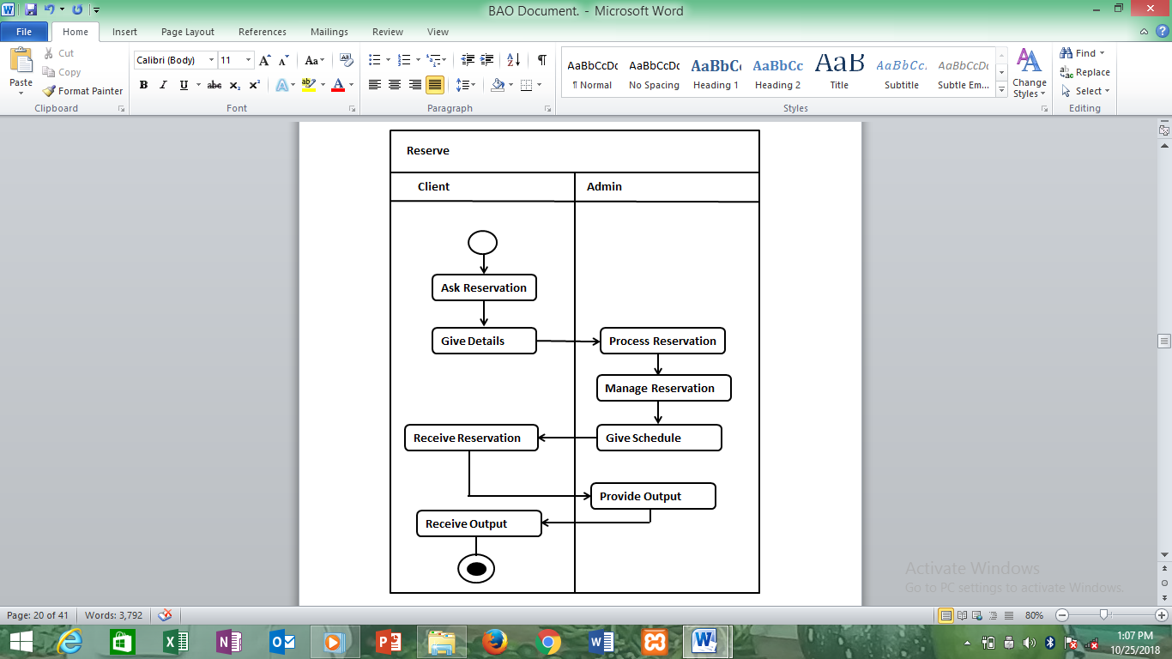**Manage Reservation Activity Diagram**

Figure #5. Manage Reservation Activity Diagram of the Developed System

Figure above shows the steps of the add, update, and archive client’s transactions

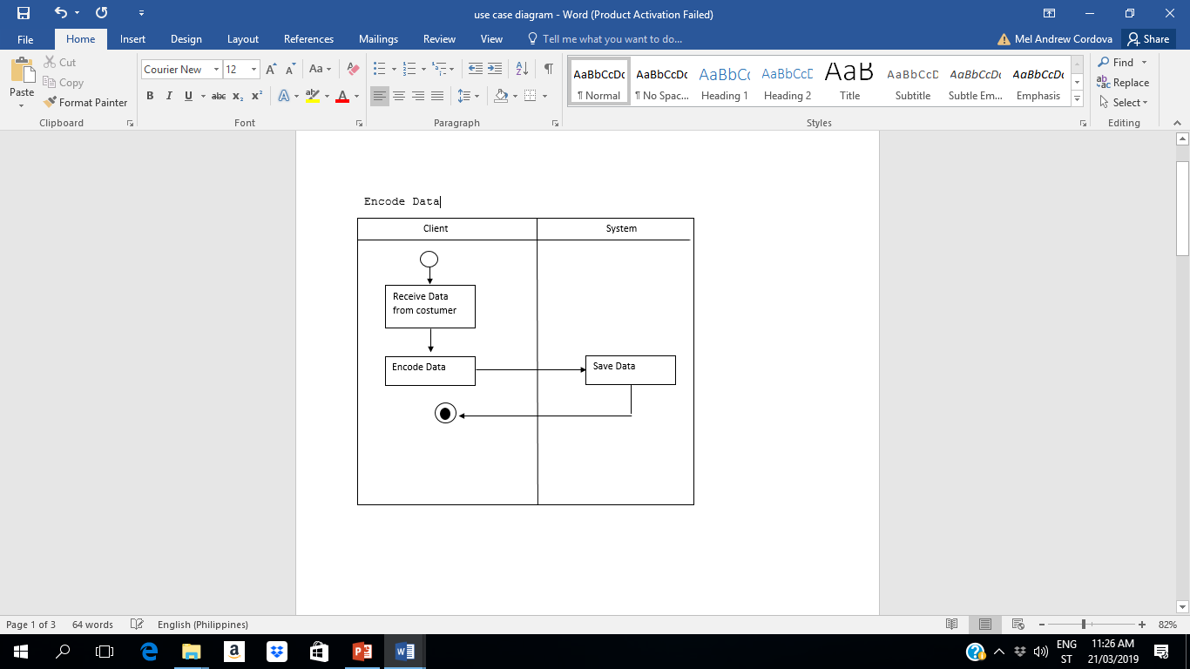 Encode Data Activity Diagram

Figure 6. Encode Data Activity Diagram of the Developed System

Figure above shows the steps of how the admin encode the data into the system.

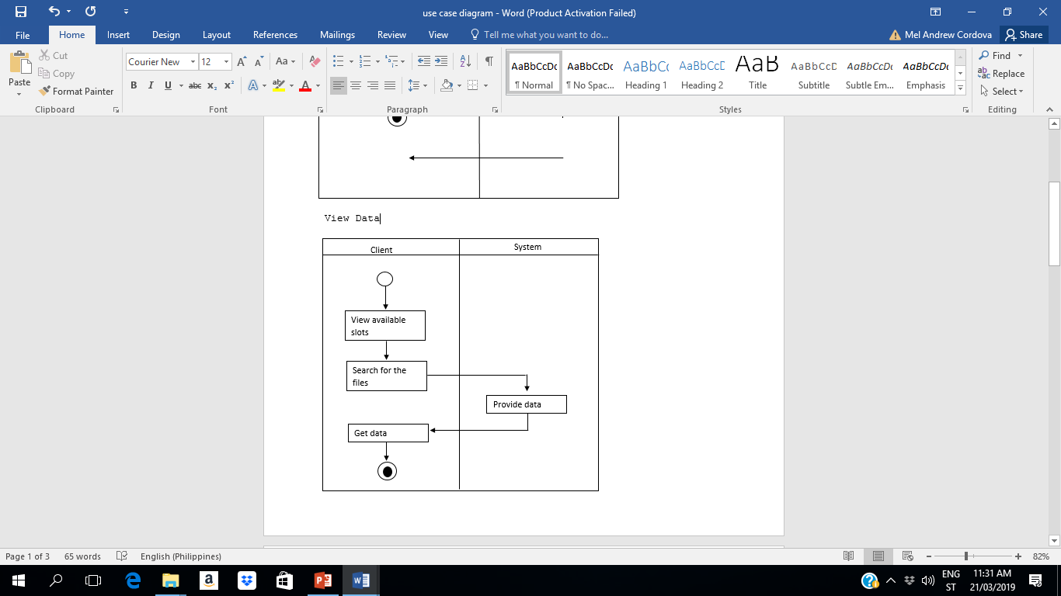**View Data Activity Diagram**

Figure 7. View Data Activity Diagram of the Developed System

Figure above shows the steps of viewing data from the system.

Generate Inventory

System

Staff

Count the sales

Count the capital

Add

Encode Data

Save Data

Figure 8. Generate Inventory Activity Diagram of the Developed System

Figure above shows the steps of how to inventory some terms of the business from the system.

Manage Information

System

Admin

Encode

Get Information

Check Information

Display

Yes

Yes

No

Update

Search

Figure 9. Manage Information Activity Diagram of the Developed System

Figure above shows the steps of how to manage the information of the business into the system.

**Decomposition Chart**

Decomposition Chart shows the break down process and its sub-processes of the whole system.

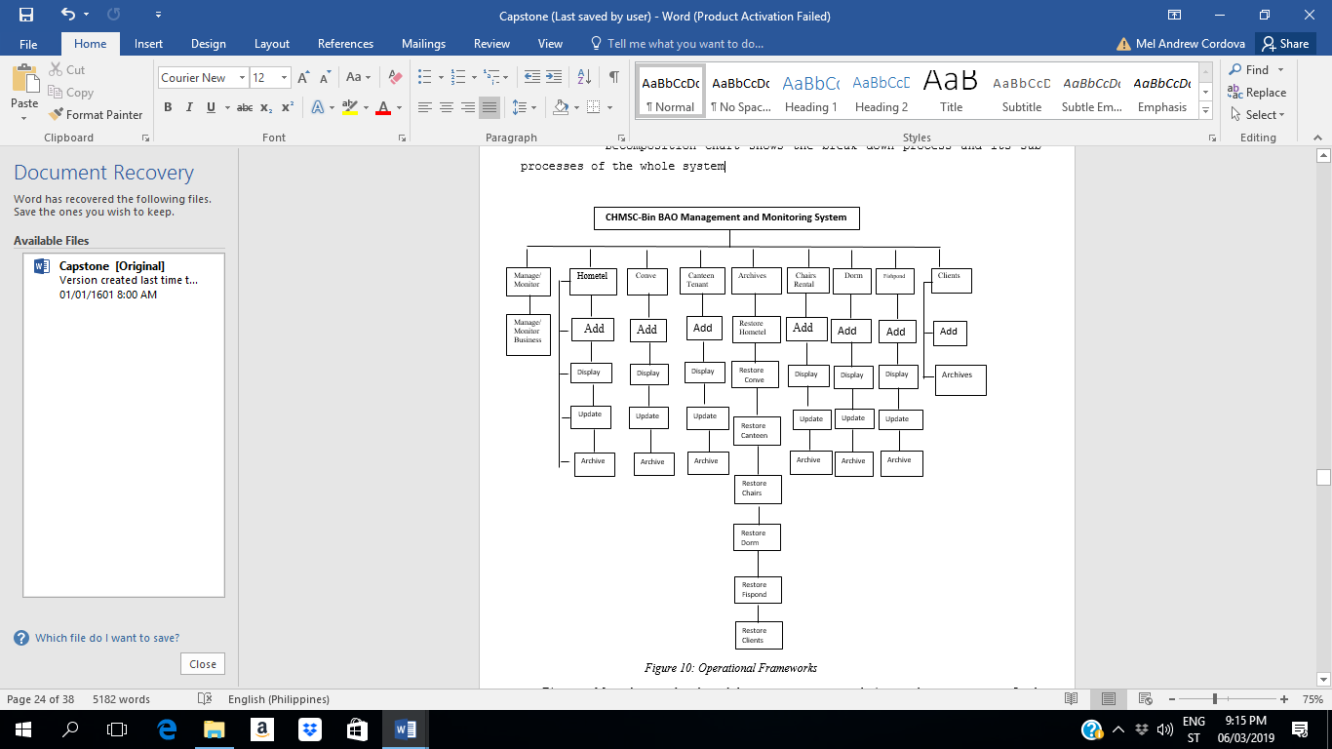

Figure #10: Operational Frameworks

Figure above shows the breakdown processes and its sub-processes of the developed system. Every process has been labelled and mark to equate the functionality of the whole system.

**Operational Frameworks**

As every steps done, the proponents review the information inputs and the processes in the proposed system for us to know what we could change to remove or add certain functionality or feature.

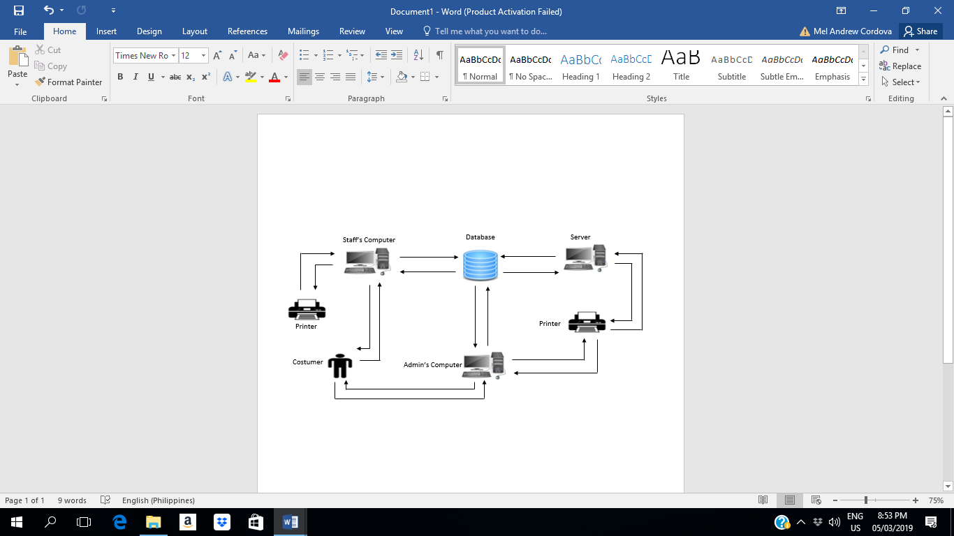

Figure #11: Operational Frameworks

Figure above shows the operational framework on the system was composed of owner PC, Database, Printer, the owner’s and staff personal computer and the server. Updates the information of customer stored in database as well as systems configuration. The information of the customer will be gathered sometimes by the staff but the one that gathered of all the information of the customer was the admin that stored and the database.

**Recommended Hardware Specification (**Server/Workstation**)**

For Property Equipment and Supplies Management System is develops and run in a perfect function, but first the client must implement the following hardware specifications:

* Microsoft Windows 7 Professional/Windows 8
* 4GB, 64-bit Processor
* 500 Gigabyte Hard Drive
* Intel Core i3 or Equivalent
* 40 Gigabytes Hard Drive (for Backup)

**Recommended Software Specification (**Server/Workstation)

* MySQL, Apache
* HeidiSQL
* Xampp
* Java NetBeans

**Entity Relationship Diagram**

Relational database management system (RDMS) is a database management system (DBMS) based on relation model or data. In conformity, the Entity Relation Diagram shows the relationship and the connection of all tables in the database in a working system

PK bill_id

FK Name_id

balance_id

payment_id

date_id

Billing

PK log_id

FK UserName_id

Password_id

bill_id

Canteen_id

chairs_id

conve_id

dorm_id

fish_id

home_id

login

Canteen

PK Canteen_id

FK Name_id

Address_id

ContactNumber_id

Date_id

PK home_id

FK Name_id

Address_id

Date_id

PK dorm_id

FK Name_id

Course_id

year_id

sec_id

HomeAddress_id

Age_id

ContactNumber_id

Sex_id

Date_id

hometel

dormitory

chairs

fishpond

PK chairs_id

FK Name_id

Address_id

Contact_id

Pieces_id

Date_id

PK fish_id

FK Name_id

NameofFish_id

Quantity_id

Feeds_id

conve

PK conve_id

FK Name_id

Activity_id

Date_id

Figure 12. shows the connection of all tables in the database requires specific information in order to work the system.

**Data Dictionary**

The tables below show the list of all tables and the data stored in the database on the CHMSC-Bin Reservation and Monitoring System. It provides the attribute, data types and also the description for each fieldnames to recognize the data being stored in the database.

Table 10. Billing

|  |  |  |  |
| --- | --- | --- | --- |
| Fieldname | Description | Type | Length |
| bill_id | Bill | INT | 5 |
| Name_id | Name  Identification | VARCHAR | 50 |
| Payment_id | Payment | INT | 10 |
| Balance_id | Balance | INT | 10 |
| Date_id | Date Name | Date |  |

Table 11. Log In

|  |  |  |  |
| --- | --- | --- | --- |
| Fieldname | Description | Type | Length |
| ID | User ID | INT | 10 |
| UserName_id | User Name  Identification | VARCHAR | 50 |
| Password_id | Password | VARCHAR | 50 |

Table 12. Canteen

|  |  |  |  |
| --- | --- | --- | --- |
| Fieldname | Description | Type | Length |
| Canteen_id | Canteen  Identification | INT | 5 |
| Address_id | Address Name | VARCHAR | 50 |
| ContactNumber_id | Contact Number | INT | 50 |
| Date_id | Date Name | Date |  |

Table 13. Chairs

|  |  |  |  |
| --- | --- | --- | --- |
| Fieldname | Description | Type | Length |
| Chairs_id | Chairs Name  Identification | INT | 5 |
| Name_id | Name  Identification | VARCHAR | 50 |
| Address_id | Address | VARCHAR | 50 |
| Contact_id | Contact Number | INT | 50 |
| Pieces_id | Pieces | INT | 50 |
| Date_id | Date | Date |  |

Table 14. Convention

|  |  |  |  |
| --- | --- | --- | --- |
| Fieldname | Description | Type | Length |
| Conve_id | Convention  Identification | INT | 5 |
| Name_id | Name  Identification | VARCHAR | 50 |
| Activity_id | Activity | VARCHAR | 50 |
| Date_id | Date | Date | 10 |

Table 15. Hometel

|  |  |  |  |
| --- | --- | --- | --- |
| Fieldname | Description | Type | Length |
| Hometel_id | Hometel  Identification | INT | 5 |
| Name_id | Name  Identification | VARCHAR | 50 |
| Address_id | Address | VARCHAR | 50 |
| Date_id | Date | Date |  |

Table 16. Dormitory

|  |  |  |  |
| --- | --- | --- | --- |
| Fieldname | Description | Type | Length |
| Dorm_id | Dormitory  Identification | INT | 5 |
| Name_id | Name  Identification | VARCHAR | 50 |
| Course_id | Course  Identification | VARCHAR | 5 |
| Year_id | Year | INT | 5 |
| Sec_id | Section | VARCHAR | 3 |
| HomAddress_id | HomeAddress | VARCHAR | 50 |
| Age_id | Age | INT | 5 |
| ContactNumber | ContactNumber | INT | 50 |
| Sex | Sex  Identification | VARCHAR | 5 |
| Date | Date | Date |  |

**Gantt Chart**

The Gantt chart assess the proponents with the effective project management throughout the whole process. It stated there of how long process will take the needs an efficient and effective time management. The Gantt chart also figured out the minimum developing time of the proposed project.

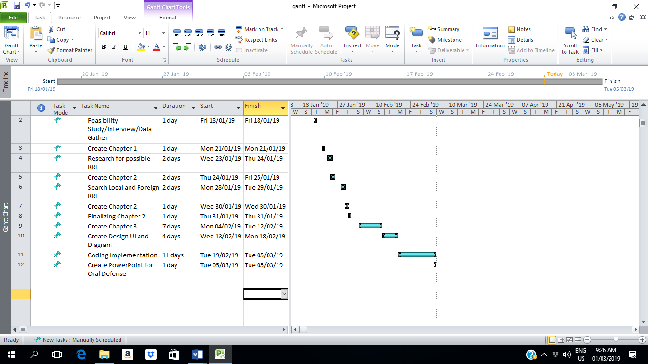

Figure 10 Gantt Chart shows the project team started January 18,2019. This was follow by the series of activities in regards to the system development. The process was aligned with the system development life cycle phase which are analysis, planning, design, implementation, evaluation and testing. This tool guides the project team on the different activity that needs to be done in succeeding days.

Time Table

The time table shows the tasks by the proponents.

Table 17. Time Table

|  |  |  |  |
| --- | --- | --- | --- |
| Task | Date Started | Date Finished | Assigned Members |
| Feasibility Study/Interview/Data Gather | 18/01/19 | 18/01/19 | Mylen Pedro  Julie Ann Gayanilo  Camila Tupas |
| Create Chapter 1 | 21/01/19 | 21/01/19 | Mylen Pedro  Julie Ann Gayanilo |
| Research for possible RRL | 23/01/19 | 24/01/19 | Mylen Pedro  Camila Tupas |
| Create Chapter 2 | 24/01/19 | 25/01/19 | Mylen Pedro  Julie Ann Gayanilo  Camila Tupas |
| Search Local and Foreign RRL | 28/01/19 | 29/01/19 | Mylen Pedro  Julie Ann Gayanilo  Camila Tupas |
| Create Chapter 2 | 30/01/19 | 30/01/19 | Mylen Pedro  Julie Ann Gayanilo  Camila Tupas |
| Finalizing Chapter 2 | 31/01/19 | 31/01/19 | Mylen Pedro  Julie Ann Gayanilo  Camila Tupas |
| Create Chapter 3 | 04/02/19 | 12/02/19 | Mylen Pedro  Julie Ann Gayanilo  Camila Tupas |
| Create Design UI and Diagram | 13/02/19 | 19/02/19 | Mylen Pedro  Julie Ann Gayanilo  Camila Tupas |
| Coding Implementation | 19/02/19 | 05/03/19 | Mylen Pedro  Julie Ann Gayanilo  Camila Tupas |
| Create PowerPoint for Oral Defense | 05/03/19 | 05/03/29 | Camila Tupas |

Please rate the developed system in terms of the following software characteristics by checking the box that corresponds to your answer. Use the legends as a guide to your answer.

**5. Excellent 4. Very Good 3. Good 2. Fair 1. Poor**

|  |  |  |  |  |  |
| --- | --- | --- | --- | --- | --- |
| **Task** | Rating  3  2  1  4  5 | | | | |
| 1.1 The design of the system is appealing to the eye of the user |  |  |  |  |  |
| 1.2 The graphics of the system is attractive |  |  |  |  |  |
| 1.3 The design of the system is easy to use and understand |  |  |  |  |  |
| 1.4 The system can monitor the data’s gather in efficient way |  |  |  |  |  |
| 1.5 The process of the system is easy to manage |  |  |  |  |  |
| 1.6 It is easy to locate of when the business is available. |  |  |  |  |  |
| 1.7 Provide correct information of all the data’s about every term of a businesses. |  |  |  |  |  |
| 1.8 Secure all the data’s |  |  |  |  |  |
| 1.9 Saves time in encoding all the data’s through the system. |  |  |  |  |  |
| 2.0 The BAO SYSTEM can accommodate a maximum amount of person |  |  |  |  |  |
| 2.1 Determines the availability of the room |  |  |  |  |  |